**DevOps Assignment (Code Build with s3 and GitHub)**

**Done By =Taha Jawaid (21k-3881)**

**Code Build with s3:**

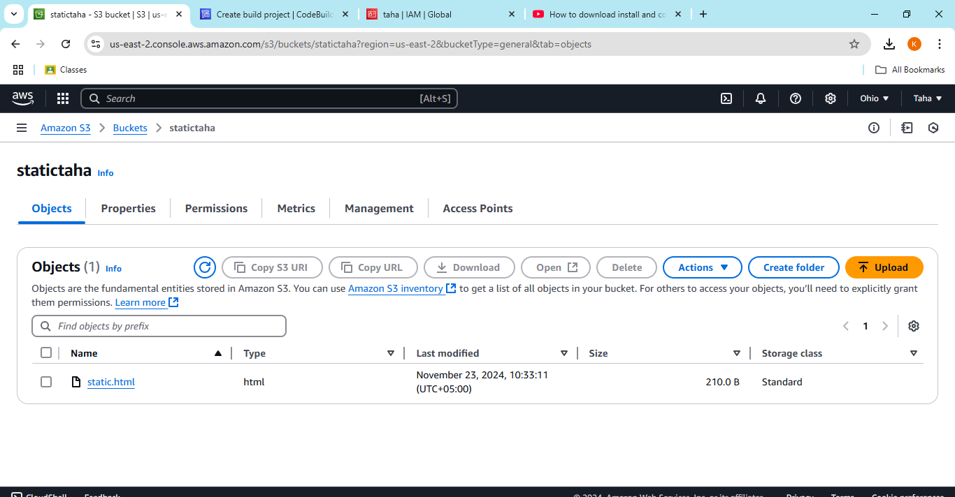

Create bucket named= statictaha and then upload static file named=static.html

Adding bucket policy for providing public access

Create IAM user named=taha

Give full permissions of ec2, s3, codebuild

Now, doig codebuild cofiguration

Below picture is the Buispec code:

version: 0.2

phases:

install:

commands:

- echo "Starting install phase - No dependencies needed for static files"

build:

commands:

- echo "Build phase - Skipping as this is a static site"

post_build:

commands:

- echo "Post-build phase - Syncing files to S3 bucket"

- aws s3 ls s3://statictaha || (echo "Bucket not found, check the bucket name or permissions" && exit 1)

- aws s3 sync . s3://statictaha --exclude "Buildspec.yml"

artifacts:

files:

- '**/*'

discard-paths: no

The project Build successfully

**For CodeBuild using GitHub:**

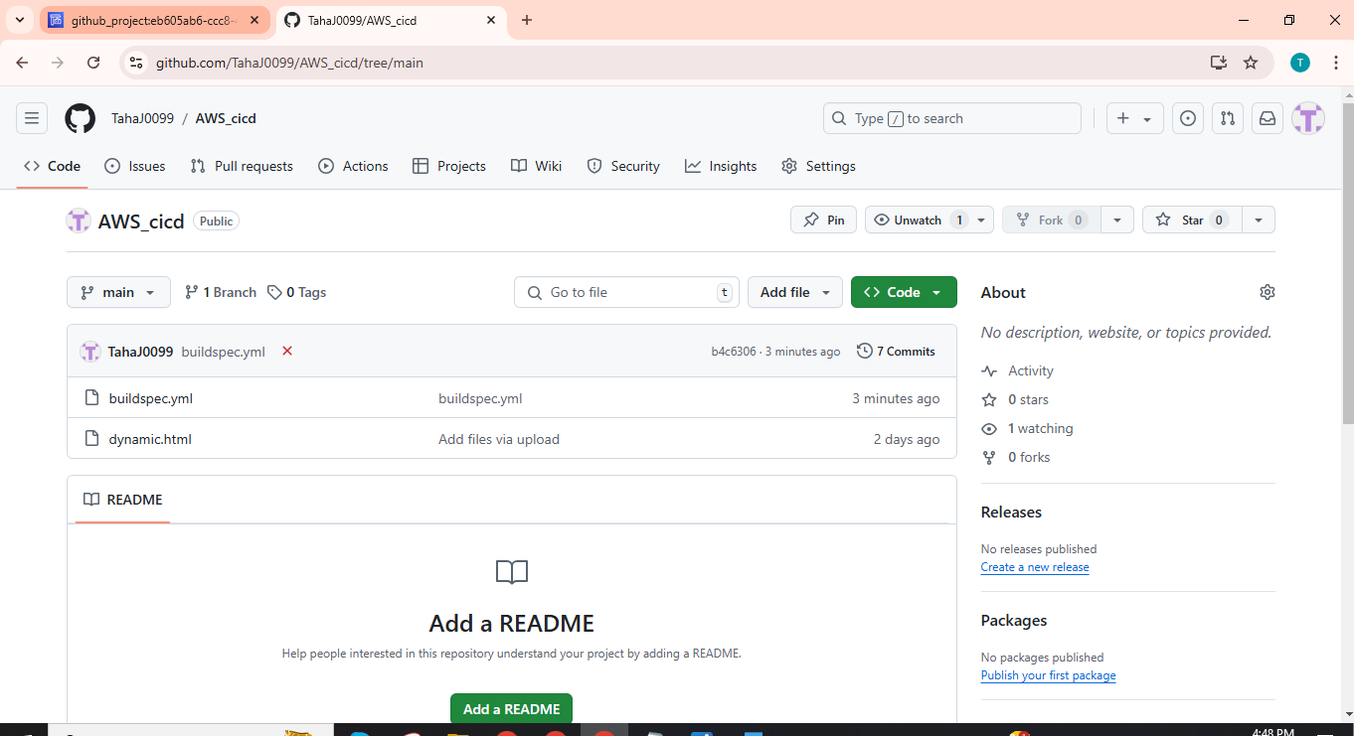

Created a new repository named=AWS_cicd and uploaded adynamic file along with buildspec file.

Below is buildspec file code:

version: 0.2

phases:

install:

runtime-versions:

nodejs: 16 # Optional if you don't need Node.js for other tasks

commands:

- echo "No installation required for static/dynamic HTML."

pre_build:

commands:

- echo "Pre-build:Running any preparation tasks..."

build:

commands:

- echo "Build:Running the build process..."

- echo "No build steps needed for static/dynamic HTML."

post_build:

commands:

- echo "Post-build:Preparing artifacts for deployment..."

- echo "Build process completed."

artifacts:

files:

- '**/*' # Include all files in the directory

base-directory: '.' # Root directory of your application

discard-paths: no

Using the same IAM User ,used for s3 before.

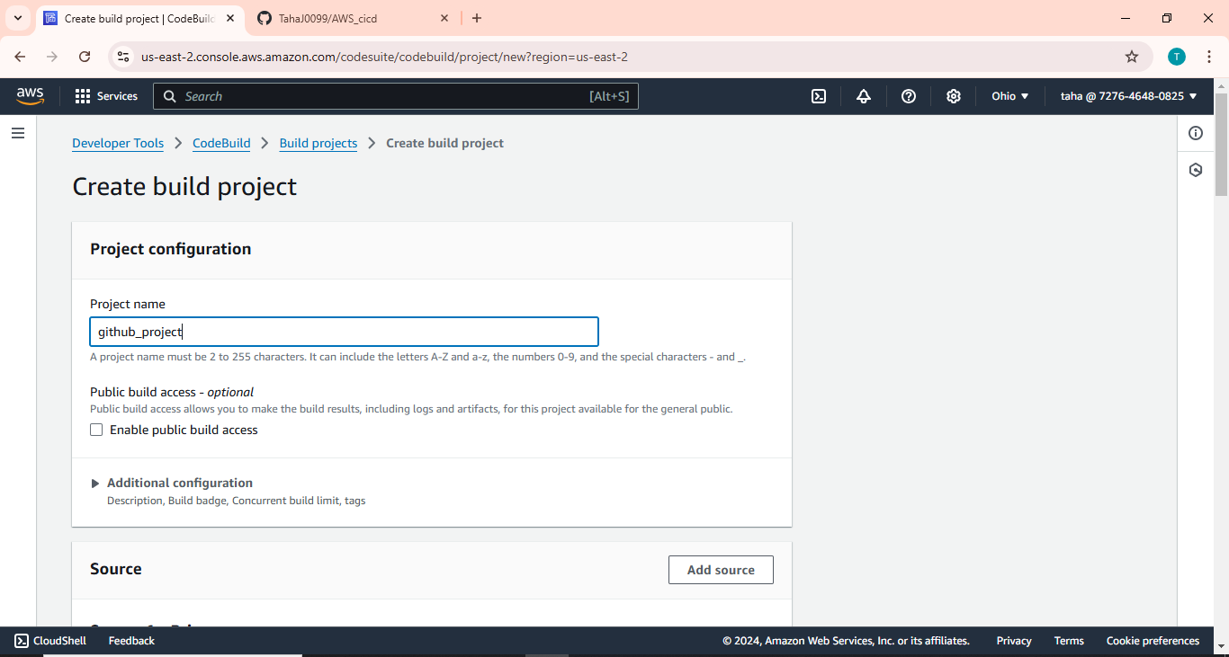

Creating a new build project named as =github_project.

Primary source is Github

Custom credentials

OAuth app

Created a new secret connection b/w AWS and GitHub as shown in the image below.

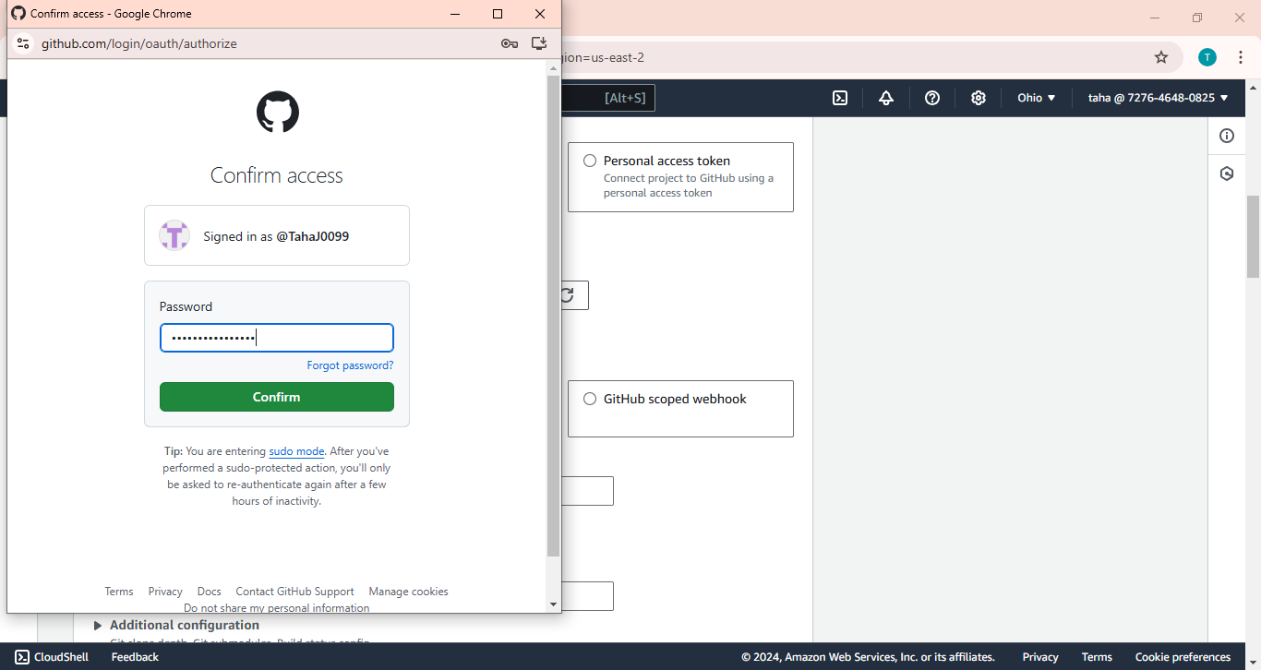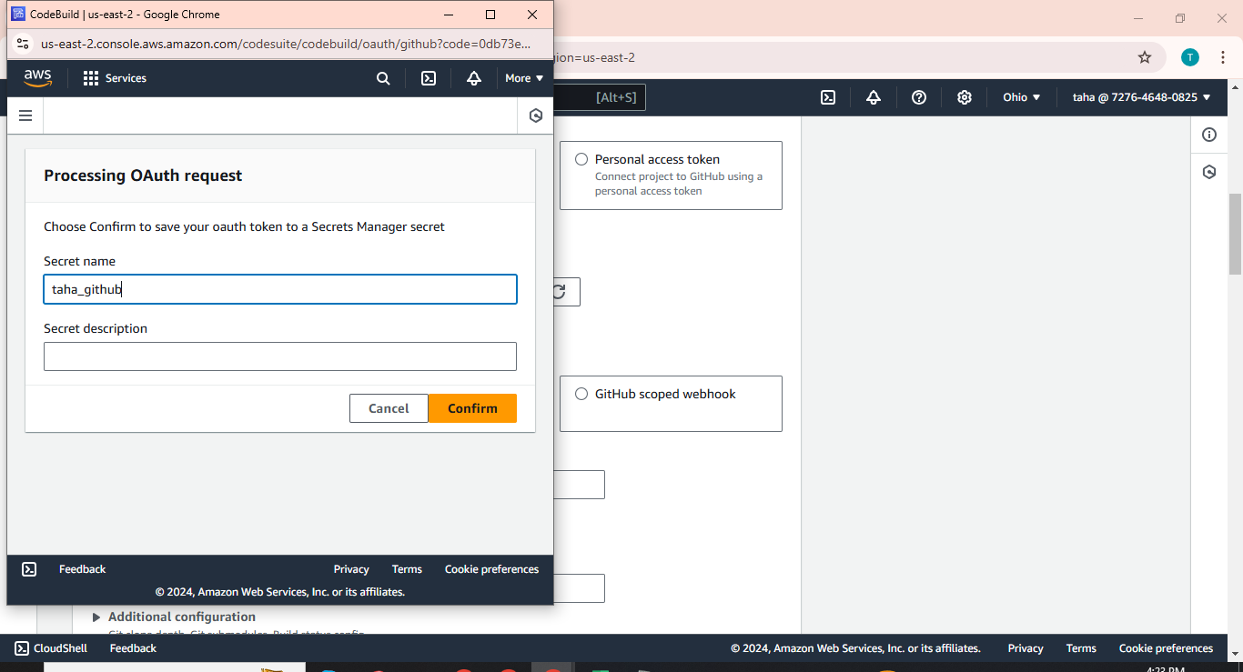

After that the connection is build b/w AWS and GitHub.

Now copy the URL of the specific repository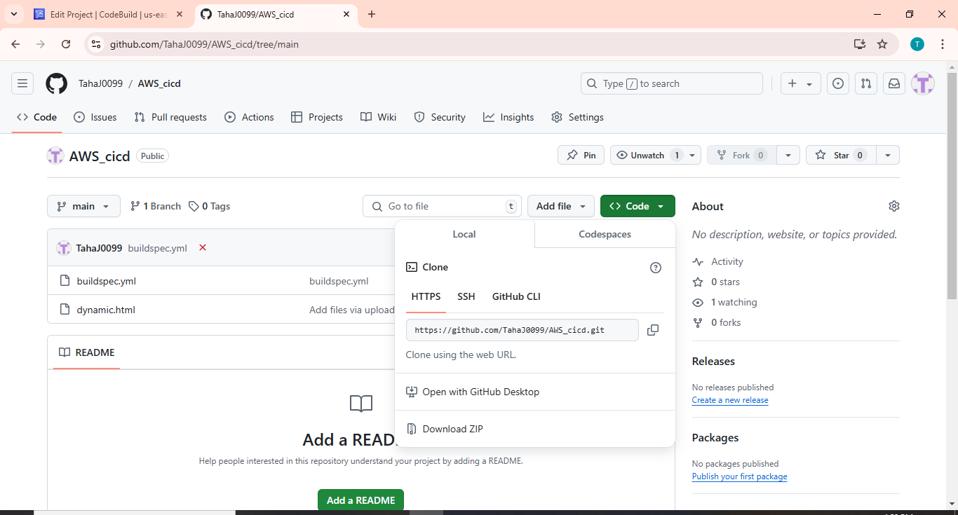

Select the Insert Build Commands and added the builspec code as written buildspec file and uploaded to GitHub repo.

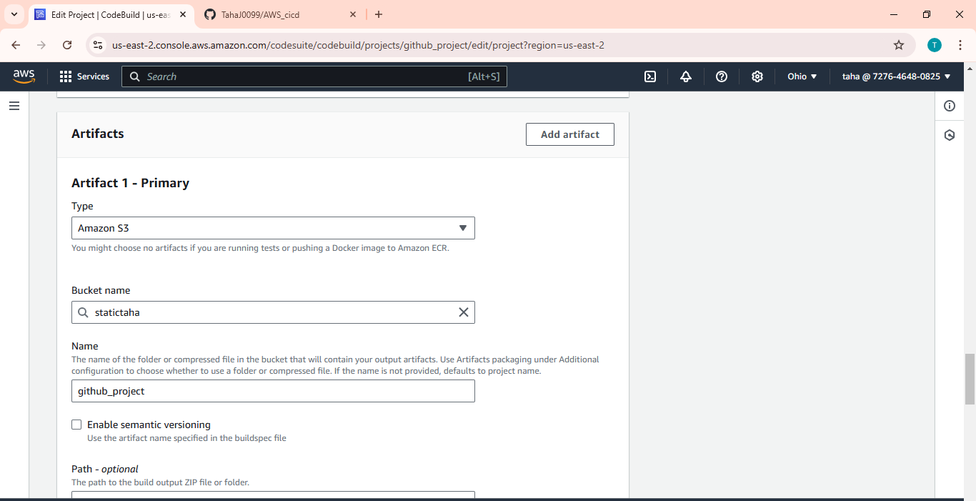

Select the Artifact and bucket in which you want to get the artifact in my case, the bucket name is=statictaha.

After that, the Code is built successfully as shown in the figure below.

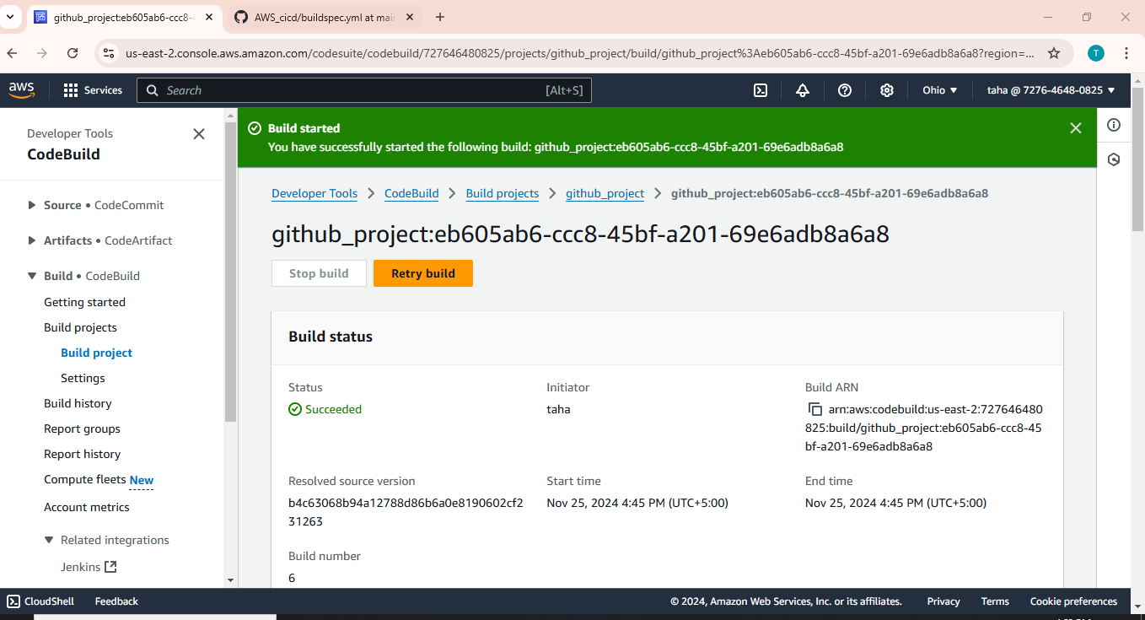

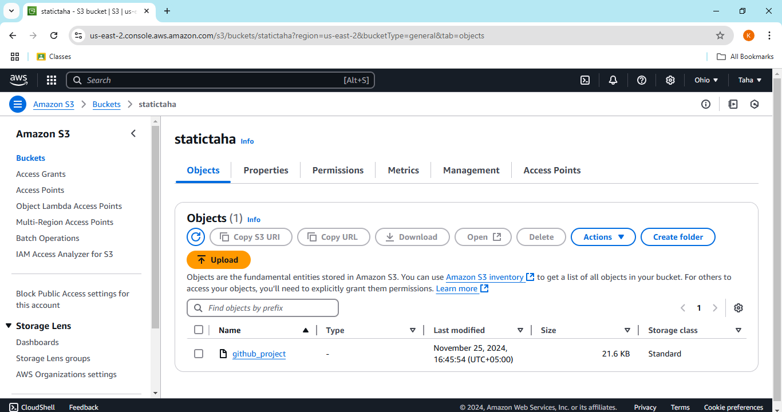

The artifact is uploaded to the bucket successfully.